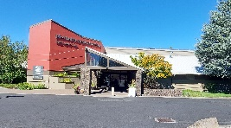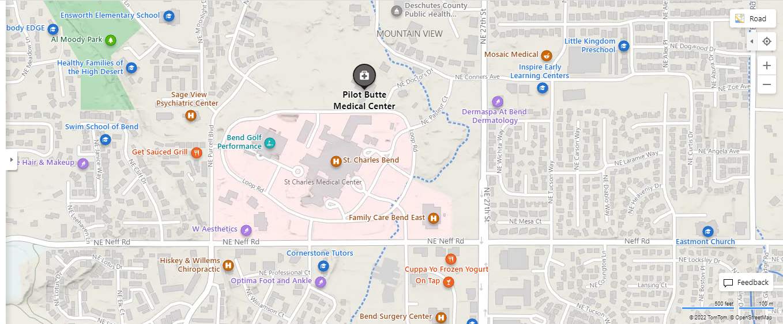

Costco

**Directions coming from East:**  **Directions coming from North:**

Take HWY 20 West to 27th Street Travel South on HWY 97/3rd Street

Turn Right (North) on 27th St. to Conners Ave. Turn Left on Greenwood/Hwy 20 (East)

Turn Left (West) on Conners Ave. Travel (3mi) to 27th St. (pass Costco)

Turn Left on Doctors Drive Go Left on 27th St. to Conners Ave 1.5mi

Continue to Pilot Butte Medical Center Turn Left on Conners Ave Turn Left on Doctors Drive Continue to Pilot Butte Medical Center

**Directions coming from West:**  **Directions coming from South:**

Take HWY 20/Greenwood Ave Eastbound Travel North on Hwy 97/3rd St.

Turn Left (North) on 27th Street Turn Right on Greenwood/Hwy 20 East

Turn Left (West) on Conners Ave. Travel (3mi) to 27th St. (pass Costco)

Turn Left on Doctors Drive Go Left on 27th to Conners (1.5 Continue to Pilot Butte Medical Center Turn Left on Conners Ave

Left on Doctors Dr. to Pilot Butte Med. Center

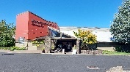 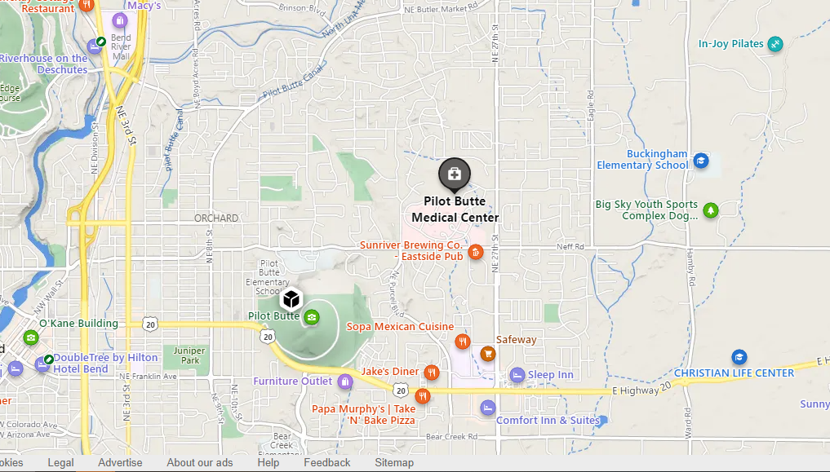

**Conners Dr. to Doctors Dr.**

**27th St.**

E. HWY 20

3RD ST

E. HWY 20

**E. Hwy 20**

